 | Epsom & Ewell F.C.  8  v  Farnham Town  Tuesday, 14th November 2017 – 7.45 p.m.
Good evening and welcome to High Road for our League match against Farnham Town! We welcome their players, supporters and officials and wish them a safe journey home, as of course we do for our own regular faces.

We met our opponents back in September when the two teams battled out an entertaining but goalless draw at the Memorial Ground. It was our 4,000th match in history, and only our second point of the season.

We were last at home on 28th October when we hosted North Greenford United, and we had to accept defeat by two goals to one against a team I thought looked very good. We then visited Chertsey Town on the Halloween Tuesday where we produced our best display of the season, yet came away defeated by a goal to nil. We totally dominated this match after conceding an early penalty but were never able to pull the goal back.

On the Saturday 4th November we travelled for our first match on the new Bedfont Sports artificial surface and found out why they are one of the top sides in the table as we were crushed 7-0. They were without doubt the best team we have played all season.

Then on Saturday we made the journey to Whitstable Town in the Second Round of the F.A. Vase, where we were edged out by three goals to two after extra time. Although admitting that the better team won on the day, we defended superbly and on another day might have been facing them tonight here in a replay. Liam Roberts scored our first goal after his penalty was initially saved, while Ben Dyson scored our equaliser to register his first goal in our colours.

Whilst today’s match is important we face two even more crucial league matches in the next seven days as we visit A.F.C. Hayes on Saturday before hosting Godalming Town next Tuesday. Your support would be really welcome. Bring your friends too!

And on that subject, please note that we have now combined the match sponsorship into one item at £60. This still includes free entry for three people, including programmes and hospitality and in a new initiative you get to choose the player of the match, which will result in a prize for that player. Alternatively, you can sponsor a player at £40 a time, so please help our club by letting a Committee member know. The new list of players is available in today’s programme. We also will be selling our new Centenary merchandise shortly, which is pictured at the back of the programme. Please help us by ordering a shirt or two!

Finally, it may be a few days late, but we shall be marking our first home game since Remembrance Sunday with a minute’s silence. The front cover is also historically significant today (see below).

Enjoy the game.

Rich
Don’t forget, you can now follow us on Social Media. Please see the inside cover for addresses.

Our cover picture is from the final London League match that our club played before World War Two on 6th May 1939, winning 4-0 against the Royal Naval Depot.
Regrettably, both our keeper David Wesley (fourth left – back row) and Geoff Collins
(fourth left – front row) were both killed during the hostilities.


Cherry Red Records Combined Counties League
Premier Division Table 2017/18
inc Saturday 11th Nov | P | W | D | L | F | A | Pts | GD | H | A
Westfield | 15 | 13 | 1 | 1 | 59 | 16 | 40 | +43 | 14/4 | 9/12
Walton & Hersham | 17 | 11 | 3 | 3 | 42 | 18 | 36 | +24 | 30/12 | 21/4
Bedfont Sports | 16 | 10 | 3 | 3 | 44 | 23 | 33 | +21 | 24/3 | 0-7
Sutton Common Rovers | 15 | 9 | 3 | 3 | 30 | 19 | 30 | +11 | 3/2 | 0-5
Camberley Town | 17 | 7 | 7 | 3 | 25 | 21 | 28 | +4 | 10/3 | 1-1
Hanworth Villa | 16 | 7 | 6 | 3 | 33 | 27 | 27 | +6 | 1-1 | 10/2
Horley Town | 15 | 8 | 1 | 6 | 26 | 31 | 25 | +5 | 2-3 | 23/12
Spelthorne Sports | 17 | 7 | 3 | 7 | 32 | 27 | 24 | +5 | 1-5 | 27/1
Knaphill | 16 | 7 | 3 | 6 | 34 | 36 | 24 | -2 | 24/2 | 2-6
Guildford City | 15 | 7 | 1 | 7 | 24 | 23 | 22 | +1 | 2/12 | 7/4
Balham | 14 | 6 | 4 | 4 | 25 | 25 | 22 | 0 | 20/1 | 25/11
North Greenford United | 16 | 5 | 6 | 5 | 29 | 28 | 21 | +1 | 1-2 | 17/3
Farnham Town | 14 | 5 | 4 | 5 | 23 | 27 | 19 | -4 | 14/11 | 0-0
CB Hounslow United | 14 | 5 | 3 | 6 | 20 | 18 | 18 | +2 | 13/2 | 2-4
Redhill | 16 | 5 | 3 | 8 | 28 | 28 | 18 | 0 | 0-5 | 6/1
Abbey Rangers | 16 | 5 | 3 | 8 | 22 | 25 | 18 | -3 | 16/12 | 17/2
Colliers Wood United | 17 | 5 | 2 | 10 | 30 | 32 | 17 | -2 | 30/3 | 2-5
Chertsey Town | 18 | 5 | 2 | 11 | 27 | 45 | 17 | -18 | 2-7 | 0-1
Banstead Athletic | 15 | 4 | 4 | 7 | 21 | 34 | 16 | -13 | 2/4 | 1-1
AFC Hayes | 14 | 4 | 2 | 8 | 18 | 26 | 14 | -8 | 28/4 | 18/11
Godalming Town | 16 | 1 | 4 | 11 | 17 | 42 | 7 | -25 | 21/11 | 13/1
Epsom and Ewell | 15 | 0 | 4 | 11 | 15 | 53 | 4 | -38 | X | X
1

Lucky Day? – 14th November
Played 14 - Won 6 Drawn 4 Lost 4 - For 26 Against 21 - PPG 1.57 - Above Average
Our Club record against today’s opponent
Played 16 - Won 8 Drawn 4 Lost 4 - For 27 Against 25 - PPG 1.75 - Good
Our Largest wins and losses against today’s opponent
1st December 2012 - W 3-1 - Combined Counties League (H)
20th March 2012 - L 1-4 - Combined Counties League (H)
Their Last Visit
25th March 2017 - Drew 2-2 - Combined Counties League

First Eleven Appearances 2017/18 - (max 19)
Name | Debut | 2016/17 |  |  |  | Career Totals
Name | Debut | App | Sub | Total | Goals | App | Sub | Total | Goals
AJAYI Tayo | 06/08/2017 | 3 | 4 | 7 | 1 | 3 | 4 | 7 | 1
BROOKS Jordan* | 06/08/2017 | 3 | 0 | 3 | 0 | 3 | 0 | 3 | 0
CASTELL Cristian* | 06/08/2017 | 2 | 4 | 6 | 0 | 2 | 4 | 6 | 0
CONNELLY Lloyd | 14/10/2017 | 6 | 0 | 6 | 1 | 6 | 0 | 6 | 1
DEWAR Ali | 29/10/2011 | 1 | 2 | 3 | 0 | 56 | 42 | 98 | 10
DYSON Ben | 12/08/2017 | 13 | 1 | 14 | 1 | 13 | 1 | 14 | 1
GRAHAM Bentley | 09/02/2016 | 3 | 0 | 3 | 0 | 20 | 1 | 21 | 3
GRANDISON Kane | 11/11/2017 | 1 | 0 | 1 | 0 | 1 | 0 | 1 | 0
GRIFFIN Reisse | 08/08/2015 | 13 | 0 | 13 | 1 | 86 | 13 | 99 | 7
HARLAND-GODDARD Tom* | 06/08/2017 | 1 | 1 | 2 | 0 | 1 | 1 | 2 | 0
HARRIS Colin | 04/08/2012 | 9 | 0 | 9 | 0 | 34 | 0 | 34 | 0
HATFIELD Jamie | 11/11/2006 | 9 | 1 | 10 | 0 | 258 | 14 | 272 | 6
HAYWARD Ben | 07/03/2007 | 5 | 1 | 6 | 0 | 248 | 29 | 277 | 18
HEAGNEY Adam | 16/08/2016 | 7 | 0 | 7 | 0 | 44 | 9 | 53 | 1
HENDRY Rob | 08/08/2015 | 12 | 0 | 12 | 4 | 80 | 22 | 102 | 27
HOUGH Kyle | 14/08/2007 | 10 | 2 | 12 | 6 | 343 | 21 | 364 | 207
JASPER Joe | 11/11/2017 | 0 | 1 | 1 | 0 | 0 | 1 | 1 | 0
LAW Franky* | 06/08/2017 | 3 | 0 | 3 | 0 | 3 | 0 | 3 | 0
LOFTUS-CHEEK Joe | 06/08/2017 | 9 | 1 | 10 | 2 | 9 | 1 | 10 | 2
MARVELL Dale | 15/01/2000 | 14 | 2 | 16 | 0 | 283 | 51 | 334 | 86
MCKAY Alex | 20/12/2008 | 6 | 1 | 7 | 1 | 137 | 38 | 175 | 13
MURPHY George | 19/03/2013 | 1 | 0 | 1 | 0 | 69 | 7 | 76 | 3
MURPHY Scott | 20/01/2007 | 11 | 0 | 11 | 0 | 23 | 2 | 25 | 1
MYERS Antony | 23/12/2006 | 1 | 0 | 1 | 0 | 76 | 33 | 109 | 9
NWACHUKWU Jason | 01/10/2016 | 9 | 4 | 13 | 2 | 26 | 20 | 46 | 3
O'BRIEN Louis* | 28/08/2017 | 1 | 3 | 4 | 0 | 1 | 3 | 4 | 0
ROBERTS Liam | 12/08/2017 | 8 | 6 | 14 | 2 | 8 | 6 | 14 | 2
ROBINSON Sam* | 22/10/2011 | 5 | 0 | 5 | 0 | 66 | 6 | 72 | 14
ROSE Daniel | 25/10/2016 | 11 | 2 | 13 | 1 | 13 | 7 | 20 | 1
SMITH Andy* | 25/08/2017 | 2 | 0 | 2 | 0 | 2 | 0 | 2 | 0
SMITH Taryn | 28/10/2017 | 2 | 1 | 3 | 0 | 2 | 1 | 3 | 0
THOMPSON Ashley | 21/08/2017 | 13 | 1 | 14 | 3 | 13 | 1 | 14 | 3
THOMSON David* | 02/09/2017 | 2 | 2 | 4 | 0 | 2 | 2 | 4 | 0
WHITE Sean | 02/08/2014 | 5 | 6 | 11 | 2 | 11 | 19 | 30 | 5
YOUNG Conor | 07/03/2015 | 8 | 0 | 8 | 0 | 9 | 0 | 9 | 0
* Player has left the club

Results and Fixtures so far
Combined Counties League – Saturday 28th October
Abbey Rangers | 0-1 | CB Hounslow United
AFC Hayes | 1-1 | Sutton Common Rovers
Banstead Athletic | 3-5 | Westfield
Colliers Wood United | 0-2 | Camberley Town
Epsom & Ewell | 1-2 | North Greenford United
Farnham Town | 3-3 | Horley Town
Godalming Town | 1-2 | Chertsey Town
Guildford City | 1-3 | Knaphill
Redhill | 1-4 | Hanworth Villa
Spelthorne Sports | 0-0 | Bedfont Sports
Walton & Hersham | 3-3 | Balham
Combined Counties League – Monday 30th October
Sutton Common Rovers | 4-2 | Knaphill
Combined Counties League – Tuesday 31st October
AFC Hayes | 3-2 | Spelthorne Sports
Bedfont Sports | 1-0 | Abbey Rangers
CB Hounslow United | 0-1 | Camberley Town
Chertsey Town | 1-0 | Epsom & Ewell
North Greenford United | 1-3 | Hanworth Villa
Westfield | 5-0 | Horley Town
Combined Counties League – Wednesday 1st November
Balham | 3-1 | Godalming Town
Combined Counties League – Saturday 4th November
Balham | 2-0 | Redhill
Banstead Athletic | 2-0 | AFC Hayes
Bedfont Sports | 7-0 | Epsom & Ewell
Camberley Town | 2-1 | Chertsey Town
CB Hounslow United | 0-2 | Walton & Hersham
Godalming Town | 1-3 | Farnham Town
Hanworth Villa | 5-4 | Guildford City
Horley Town | 0-5 | Abbey Rangers
Knaphill | 3-2 | Colliers Wood United
North Greenford United | 3-4 | Sutton Common Rovers
Spelthorne Sports | 1-3 | Westfield
Combined Counties League – Tuesday 7th November
Camberley Town | 3-1 | Knaphill
Walton & Hersham | 9-1 | Banstead Athletic
Combined Counties League – Wednesday 8th November
Colliers Wood United | 1-2 | Farnham Town
Buildbase F.A. Vase - Second Round – Friday 10th November
Walton & Hersham | 2-1 | Hanworth Villa
Buildbase F.A. Vase - Second Round – Saturday 11th November
Farnham Town | 2-3 | Bridgwater Town
Results and Fixtures so far
Buildbase F.A. Vase - Second Round – Saturday 11th November
Meridian VP | 0-3 | Horley Town
Westfield | 1-0 | Canterbury City
Whitstable Town | 3-2+ | Epsom & Ewell
Combined Counties League – Saturday 11th November
Abbey Rangers | 2-2 | Balham
Chertsey Town | 1-4 | North Greenford United
Colliers Wood United | p-p | CB Hounslow United
Guildford City | 1-1 | Camberley Town
Knaphill | 1-0 | Spelthorne Sports
Redhill | p-p | AFC Hayes
Combined Counties League – Monday 13th November
Sutton Common Rovers | V | Spelthorne Sports
Surrey Senior Cup – Tuesday 14th November
Dorking Wanderers | V | Godalming Town
Combined Counties League Cup – Tuesday 14th November
Bedfont Sports | V | Walton & Hersham
North Greenford United | V | Colliers Wood United
Combined Counties League – Tuesday 14th November
Epsom & Ewell | V | Farnham Town
Knaphill | V | Horley Town
Westfield | V | CB Hounslow United
Combined Counties League – Wednesday 15th November
Guildford City | V | Balham
Combined Counties League – Saturday 18th November
Abbey Rangers | V | Colliers Wood United
AFC Hayes | V | Epsom & Ewell
Balham | V | Westfield
Banstead Athletic | V | Knaphill
Camberley Town | V | North Greenford United
Farnham Town | V | CB Hounslow United
Godalming Town | V | Bedfont Sports
Hanworth Villa | V | Sutton Common Rovers
Horley Town | V | Chertsey Town
Redhill | V | Walton & Hersham
Spelthorne Sports | V | Guildford City
Combined Counties League – Monday 20th November
Sutton Common Rovers | V | Horley Town
Combined Counties League Cup – Tuesday 21st November
Knaphill | V | Kensington Borough
Combined Counties League – Tuesday 21st November
Epsom & Ewell | V | Godalming Town
Westfield | V | Hanworth Villa

From behind the goal
Epsom & Ewell 1-2 North Greenford United
Combined Counties League - Premier Division - Saturday 28th October 2017

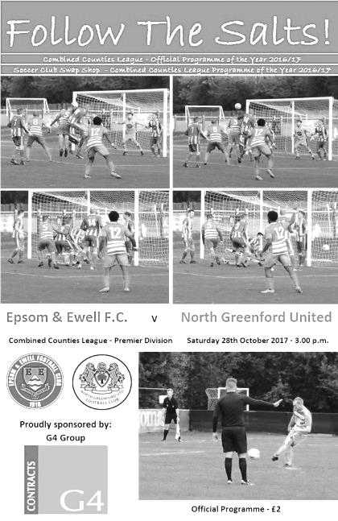
League disappointment as North Greenford outplay Salts

A 78th minute goal from Nathaniel Mensah, his second of the match, was enough to secure the three points for the visitors at High Road. Credit is due to our boys for holding out so long as North Greenford United dominated for large periods and not so long ago this match would have ended in a heavy defeat.

A problem that has continued throughout the season is availability and we haven't come close yet to naming an unchanged team. Yet again, three starters were missing following our win at Rusthall for a number of reasons and so Ben Dyson came back into the starting eleven as well as Liam Roberts and Scott Murphy; the latter taking the arm band in the absence of Jamie Hatfield.

The opposition were on a good run of form and were on top from the start, but without causing too much worry as we restricted them to a couple of low shots, although we did have to clear one shot off the line. For our part, we had created very little but did have a great opportunity in the 26th minute when Dyson made a good run down the left. His cross was only half cleared to Roberts who twisted and turned in the area before sending the ball in, where it eventually fell to Dale Marvell, but his shot went just over the bar from no more than ten yards out.

We need to take our chances right now and we were made to pay for the miss just five minutes later as Mensah tried his luck with a low drive from twenty-five yards out and the ball appeared to surprise Conor Young in our goal, the ball nestling in the far corner. I found out afterwards that the reason for this was that it had taken a deflection on the way through.

Although the goal might have been unfortunate in its manner, it was hard to deny North Greenford the lead as they had held a large majority of possession in this opening half an hour. In fact it was somewhat of a surprise when we equalised. Kyle Hough made some space down the right wing and he squared the ball in for Roberts who got a toe to the ball just before the defender, who brought him down in a heap

and left the referee with a very easy decision. Hough then tucked away the penalty in his usual clinical manner in the 34th minute.

The visitors continued to press for the remainder of the half although we were defending fairly well. They were starting to get a little frustrated, frequently running offside and it did appear that we were getting the majority of the decisions at this point. Even so, I felt that we needed a bit more of the ball if we were to avoid defeat as the continual pressure would surely tell otherwise.

And this nearly happened just five minutes into the second half when a good move on the left wing came back in and then the ball was fed through to Sandro Costa, but his low strike from just twelve yards was superbly deflected wide by Young. A minute later the ball was in our net but was ruled out. A cross in from the right wing was headed back across goal where it was forced in from close range, but the header had come from an offside position and whilst the flag wasn't seen until after the ball had gone in, it had been raised immediately and the referee to his credit went over and checked with the Assistant before correctly disallowing the goal.

We nearly surprised them with a Roberts free kick that the visiting keeper Ashley Davy chose not to come for and the ball bounced in the six yard box and skidded straight through, just beyond the far post, but our attacks were still infrequent. Glyn chose to put one of our new boys, Taryn Smith on for Dan Rose and he played in a more advanced position and acquitted himself well, even if he did pick up what looked like a somewhat harsh booking. In the meantime an overhead kick went straight at Young from 12 yards out while Reisse Griffin went on another forty yard run, but instead of at Rusthall where he went straight through and scored, this time he struck the ball over from thirty yards.

Unfortunately though, the visitors went ahead for good twelve minutes from time. The ball was fed in from the left wing to Mensah with his back to goal, but he turned and fired in a low shot that went in off Young's left hand post. This was harsh on our defenders who had held out for so long, but in all honesty it would have been a travesty had North Greenford failed to take all three points as I felt they were one of the better sides we had faced this year so far.

For our boys we have to take the positives out of this match, and there were a few, and add them to the returning players for Tuesday's match at Chertsey and we should have every chance of picking something up at Alwyns Lane.

Epsom and Ewell: Conor Young, Adam Heagney, Ben Dyson, Scott Murphy ©,
Reisse Griffin, Ashley Thompson, Liam Roberts, Dan Rose, Kyle Hough,
Dale Marvell, Lloyd Connelly

Sub: Taryn Smith for Rose (64), Ali Dewar for Lloyd Connelly (75)

Sponsors Player of the Match: Reisse Griffin

From behind the goal
Chertsey Town 1-0 Epsom & Ewell
Combined Counties League - Premier Division - Tuesday 31st October 2017

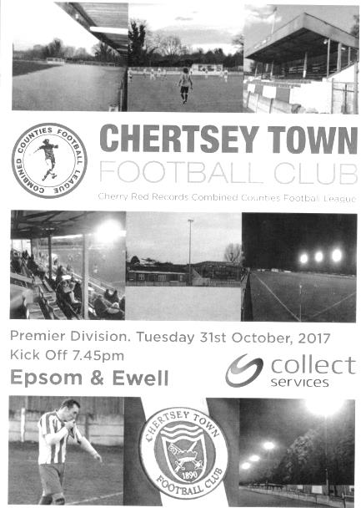
Epsom "tricked" on Hallowe'en

Despite a vastly improved performance, arguably our best of the season (including the win at Rusthall) we were consigned to defeat by an early penalty, although missed chances and an extremely inconsistent officiating display really didn't help our cause.

Once again Glyn was forced into changes with the unavailability of Reisse Griffin, Ashley Thompson and Kyle Hough, although Rob Hendry, Alex McKay and Bentley Graham were available and came into the starting eleven, as did new boy Taryn Smith who did well in his brief cameo on Saturday against North Greenford United.

The first ten minutes were mostly controlled by the visitors but nothing alarming occurred until the 12th minute when Conor Young raced out to get the ball ahead of a Chertsey striker and brought him down in the area. The striker was running away from the goal and I'm sure Young will have instantly regretted his challenge but the damage was done and Bukele Mukidi sent him the wrong way from the spot to give the hosts an early lead.

We had another scare five minutes later when their left back Ben Geraughty made a good run on the left and sent a dangerous ball straight across our six yard box but fortunately no one was there to apply the finishing touch. It should be noted that this attack was very much on the break, as by this time we had started to push the hosts back down the hill with Hendry in particular causing a lot of trouble on the left wing. With the clock on 20 minutes he beat three men and got to the touchline to roll the ball back for Lloyd Connelly to side foot in from eight yards. However, the ball took a bit of a bobble and the strike cleared the bar!

We were also suffering from some increasingly erratic decision making from the official, who had a ten minute spell midway through the first half that was as poor as any I've witnessed with six or seven decisions in a row given the wrong way and culminated with a clumsy challenge on Smith inside the Chertsey box. Somehow our man stayed on his feet but there was no advantage of any kind. It was a clear penalty and when people

complain about players going to ground too early, this incident made you realise exactly why it happens so often, as effectively Smith was punished for staying upright.

With a great chance spurned and a penalty denied, it was easy to forget that we were well on top in this match and that more chances would surely follow. Chertsey clearly believed that the main threat was Hendry and in a thirteen minute spell, three different players were booked for cynical fouls on him. At least the referee had recovered his composure to get those decisions right by then.

The second half would be tougher going up the hill, but the next forty five minutes contained a superb display across the park from our boys as the high tempo they had employed in the first half, continued unabated. Connelly picked up a yellow card for wasting time after kicking the ball in the net, and although he had received a warning about this in the first half, it was still an awful decision and a card was completely unnecessary as we were trailing at the time. Some referees go looking for trouble when there is none to be found and this was definitely the case in this match!

Hendry was next to strike at goal in the 55th minute after a low cross from the right, but his shot was also just over the bar. The visitors threatened sporadically and Scott Murphy made a good saving challenge, before we escaped in the 70th minute when a low left wing cross just needed to be headed in by a stooping attacker at the far post, but he headed the ball over the top of the empty net.

The rest of the match was played in the Chertsey half, but with no shots on target and an impressive show of time wasting by the keeper, Tom Bryant, who was told to hurry up by the referee on at least eight occasions, yet somehow didn't receive a card of his own. As time ran out Dale Marvell was unable to get a proper connection to a deep cross from the right and in the final moments Connelly held up a deep ball well for substitute Sean White to strike at goal but his attempt from the edge of the area was well wide. Ultimately for all our hard work, we had managed just one shot on target, way back in the tenth minute and Bryant finished with a clean jersey.

It was cruel to lose this match as we really need a couple of breaks right now, and to not secure any points when we had been so dominant is tough to take. Still, aside from the result, there are many positives to note from this performance and our work rate in particular was superb throughout. I believe now that we are on a level with many of the teams in the lower half of the table now, so points will start to come, but we have a lot to make up and we now sit nine points adrift of the teams outside the bottom three with one third of the season having now passed.

Epsom and Ewell: Conor Young, Adam Heagney, Jamie Hatfield ©,
Alex McKay, Scott Murphy, Dan Rose, Rob Hendry, Dale Marvell,
Lloyd Connelly, Bentley Graham, Taryn Smith

Subs: Sean White for Rose (60), David Thomson for Murphy (71),
Jason Nwachukwu for Hatfield (88)

Club Records - 14th November
Date | Day | Competition |  | Opponents |  | Scorers
14/11/25 | Sat | Surrey Senior League | H | Leyland Motors | 0-1
14/11/36 | Sat | Surrey Senior Cup 3q | H | Beddington Corner | 2-1 | J.Jones (pen), H.Pullen
14/11/53 | Sat | Corinthian League | H | Grays Athletic | 4-2 | B.Wiles (2), B.Brumwell, J.Crane
14/11/59 | Sat | Surrey Senior Cup 3q | A | Chertsey Town | 3-4 | K.MacDonald, J.Birch, J.Fennell
14/11/64 | Sat | Athenian League 1 | H | Erith & Belvedere | 2-1 | T.McGrogan, B.Mackay
14/11/70 | Sat | Surrey Senior Cup 2q | H | Camberley Town | 1-2 | J.Jennings
14/11/81 | Sat | Isthmian League 1 | H | Chesham United | 3-1 | S.Hill, T.Tuite, o.g.
14/11/87 | Sat | Isthmian League 2s | A | Newbury Town | 0-0
14/11/92 | Sat | Isthmian League 3 | H | Leighton Town | 1-4 | M.Alcindor
14/11/99 | Sun | F.A. Vase 2 | H | Cowes Sports | 1-1+ | S.Latuske
14/11/07 | Wed | Combined Counties  Premier Division | A | Colliers Wood United | 1-1 | D.Jackson
14/11/09 | Sat | F.A. Vase 2 | A | Moneyfields | 3-2 | M.Jarman (2), D.Marvell
14/11/10 | Sun | F.A. Vase 2 | H | Bracknell Town | 4-0 | K.Hough, D.Stevens, A.McGregor, M.Jarman
14/11/15 | Sat | Combined Counties  Premier Division | A | Knaphill | 1-1 | D.Cooper-Smith
Historical Decades
Date | Day | Competition |  | Opponents |  | Scorers
90 years ago – Epsom Town F.C.
12/11/27 | Sat | Amateur Cup 3q | H | Met Police | 0-3
80 years ago – Epsom F.C.
13/11/37 | Sat | London League Cup 1  replay | A | Tilbury | 3-3+ | J.Jones (pen), T.Winship, D.Silbury
70 years ago – Epsom F.C.
15/11/47 | Sat | Friendly | H | Oxford University | 1-4 | T.Rochester
60 years ago – Epsom F.C.
16/11/57 | Sat | Amateur Cup 3q replay | A | Molesey | 5-1 | J.Bangs (3), J.Sorensen,  E.Watkins
50 years ago – Epsom & Ewell F.C.
11/11/67 | Sat | Amateur Cup 3q replay | A | Lion Sports | 0-1
40 years ago – Epsom & Ewell F.C.
12/11/77 | Sat | Isthmian League 2 | A | Willesden | 3-1 | F.Allen (3)
30 years ago – Epsom & Ewell F.C.
14/11/87 | Sat | Isthmian League 2s | A | Newbury Town | 0-0
20 years ago – Epsom & Ewell F.C.
15/11/97 | Sat | Isthmian League 3 | A | East Thurrock United | 1-3 | A.Nimmo
10 years ago – Epsom & Ewell F.C.
14/11/07 | Wed | Combined Counties  Premier Division | A | Colliers Wood United | 1-1 | D.Jackson

History Corner – 14th November
92 years ago today we hosted Leyland Motors in what would prove to be a very successful season for us as we would win the Surrey Senior League for the first time. However, nobody told our opponents as they visited West Street for the first time, found it to their liking and won 1-0!

Following this defeat we would set a club record of twenty straight wins in League and League Cup matches that would extend over a year and a half as we raced to the title. In fact we would only lose two league matches all season. This was one, and yes, you’ve guessed it, Leyland Motors also beat us when we visited their Richmond Road ground in February 1926. In fact we didn’t even score as we lost 2-0! Unlike the other, more famous Richmond Road ground occupied by Kingstonian, this ground still exists.

84 years ago this week we defeated Isthmian League Leytonstone in the Final Qualifying Round of the F.A. Cup, where despite trailing at the half, we came through with three goals to reach the First Round Proper for the only time in our history and would go on to face Clapton Orient away from home, narrowly being defeated 4-2.

80 years ago this week we visited Tilbury for a London League Cup replay. We had drawn 1-1 at West Street earlier in the season but this 3-3 draw after extra time at their old Orient Field ground really caused an issue, as by the time we had arranged a second replay back at West Street, and won it rather surprisingly 8-1, it was February 1938 and incredibly too late to stage the rest of the competition! So the League held it over into the following season and didn’t run a separate competition for 1938/39.

70 years ago this week we hosted Oxford University in a friendly, losing 4-1 at West Street. This team contained many of the players that would go on to form the combined and extremely famous Pegasus team that would dominate Amateur Football for a few years in the early Fifties, winning the Amateur Cup twice in 1951 and 1953. Making his debut this day for the University was Ken Shearwood, who was Centre-Half in their two victories, both watched by 100,000 spectators at Wembley Stadium. Ken wrote the book about the famous club which is a great read, and he recently celebrated his 96th birthday!

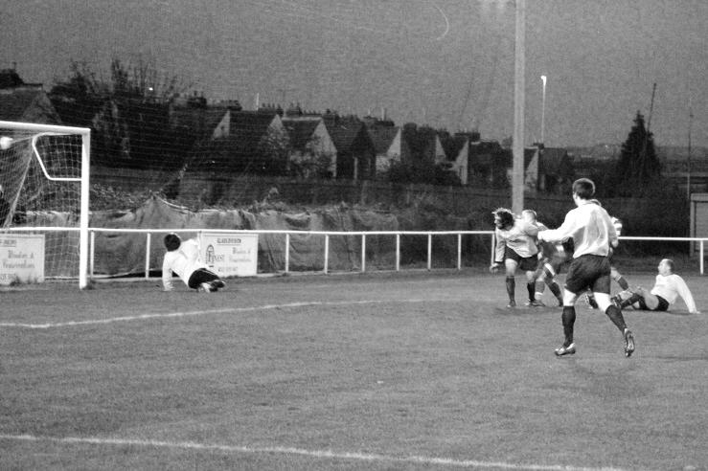
60 years ago this week we visited Molesey for the first ever time in an Amateur Cup replay, having drawn 1-1 at West Street a week previously. Johnny Bangs scored a hat trick as we cruised through 5-1 this time at Walton Road.

40 years ago this week it was Frank Allen’s turn to score a hat trick as we won 3-1 at Willesden on our way to the Isthmian League Division Two title. Willesden are long gone but the ground remains as the National Hockey Centre.

8 years ago today we had a memorable fixture at Moneyfields in the F.A. Vase on the windiest day I’ve ever encountered. Huge Slabs of wood were lifted and dropped again at the far end of the ground and the match was one of the few played that day with even nearby Portsmouth being postponed! We had the wind first half but trailed before going 2-1 up before the break. However, a 40 yarder with the wind gave Paul Borg no chance and I feared the worst at 2-2, before Mark Jarman scored a superb winner into the roof of the net, perfectly captured by his mum!

From behind the goal
Bedfont Sports 7-0 Epsom & Ewell
Combined Counties League - Premier Division - Saturday 4th November 2017

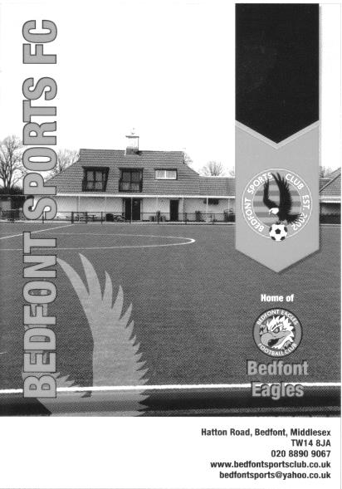
Salts scattered by rampant Sports

On all our previous visits to play Bedfont Sports we had avoided defeat, but on Saturday our seventh visit ended with a defeat by seven clear goals.

In terms of records, this was our heaviest defeat in all competitions since losing 7-0 in Ware in December 2005, but the last time we lost in the League by this many goals and didn't have the excuse of a sending off to use in our defence was way back in 1968 when Lewes beat us 10-0! There were times when I feared that this tally might be reached at times as Bedfont Sports played some very nice football throughout and totally deserve to be holding second place in the League.

However, we were the architects of our own downfall on more than one occasion in this match and never really recovered from a three goal burst early in the first half that ended the match as a contest almost before it had begun. Whilst everyone at Epsom and Ewell will be trying to forget this in a hurry, at least it will be memorable for Darryl Sanders as he ended up with five goals, becoming the fourth player to score a hat trick against us this season.

Although defence naturally comes under the spotlight after results like this, I thought they battled manfully and it was arguably in midfield where we were most outmatched, while up front we have one penalty to our credit from our last three matches and with Kyle Hough missing again today, we looked ever so lightweight up there.

A good example of this came as early as the second minute when we made what would prove to be a rare venture into the Bedfont penalty area. The ball fell for Taryn Smith but his shot was blocked to Jason Nwachukwu whose shot also had the pace taken off it by a defensive block. We really aren't getting the breaks at the moment, but you felt that Hough would have found the net, had he been there.

The home side got into the game soon after but didn't find the target in the early stages. That changed in the 17th minute when the ball was sent across our six yard box but we were unable to clear it and the ball came back in from the left to Sanders who scored from close range.

It got worse in a hurry after that and we conceded a penalty in the 20th minute. From where I was, it appeared as though a poor back pass was responsible with Alex McKay having to pull his opponent back. Certainly that's what the Assistant confirmed when I asked him at half time. However, it looked like a minimal pull with their player not even going to ground,

which we learned at Chertsey is usually the only time a penalty will be given. Not this time, and before we could get that out of the system it was 3-0 when we were caught pushing forward and they broke on the right, with their player cutting in before squaring the ball to Sanders who recorded his hat trick in just five minutes with just 22 minutes on the clock.

The remainder of the half followed a similar pattern with our boys chasing everything but not really looking like a coherent unit for much of the match. At least the fourth goal was an impressive one we could do little about with a fine ball down the right, a deep cross and a volleyed finish in the 33rd minute from Jacob Lambe.

Conor Young was finding himself to be the busiest man on the pitch and he made two fine saves, with one in particular, tipping a low shot over the bar, being a very good one. There was just time for the home team's Michael Kinsella to pick up a booking for a nasty foul on Rob Hendry as he threatened to break through. Although from our angle it looked cynical rather than dangerous, people from opposite sides of the field felt that a red card should have been issued, but at least Hendry was well enough to take the free kick himself and from 30 yards he forced the home keeper Rouke Pickford into a decent save that was gathered at the second attempt. Still, as the players trooped off at half time, the big question was really about how many we would concede.

Recent heavy defeats this season have mostly occurred in the first half with the second half being more even as the opposition eased off. However, to credit Bedfont Sports, they kept pressing us with our boys rarely able to make a tackle, with one notable exception when Taryn Smith got in the way of Dan Rose! Just after the hour the home side hit the post and despite Adam Heagney hitting the Bedfont crossbar with a powerful twenty-five yard strike, we went 5-0 down in the 64th minute when Matt Riggs was spare at the back and finished easily past the exposed Young and when Sanders scored his fourth and their sixth goal two minutes later it was very similar in nature to the fifth goal.

At this point Liam Roberts was introduced, probably to save Hendry from any more punishment after being kicked more than anyone in the last seven days, and as has often been the case this season, he added a spark for a while. Smith set him up on the right and he found Ashley Thompson with a clever pull back but Thompson went for power instead of placement twelve yards out and scuffed the ball just wide of Pickford's left hand post. In the 86th minute Sanders scored number seven as the ball fell kindly for him to curl the ball into the far corner. In response, there was just time for Roberts to get on the end of a Smith cross but his volleyed finish found the side netting from a narrow angle.

Overall it is quite easy for me to say, having had the "pleasure" of watching every match this season, that Bedfont Sports were the best team we have met so far, and whilst the result and of course the score are disappointing, the next four matches will tell us much more about our eventual end of season report card as we travel to Whitstable Town before facing three of the lower teams in Farnham, AFC Hayes and Godalming Town.

Epsom and Ewell: Conor Young, Adam Heagney, Jamie Hatfield ©, Reisse Griffin, Alex McKay, Dan Rose, Rob Hendry, Ashley Thompson, Taryn Smith, Jason Nwachukwu, Lloyd Connelly

Subs: David Thomson for Hatfield (45), Liam Roberts for Hendry (69), Sean White for Nwachukwu (75)

Tony Ford – Combined Counties League Vice-Chairman
Our club is sad to announce the passing of Tony Ford. Over the years he has held the posts of Vice Chairman, often deputising for the Chairman, Secretary, Fixture Secretary, Bulletin Editor & Assistant Referees' Secretary of the Combined Counties League (CCL) with great distinction.

He made it a point of visiting Clubs in their league in a very informal friendly manner, being there to help them in any way if necessary but never imposing himself and will be greatly missed by all involved in non-league football.

He was also heavily involved recently in the introduction of the Development & Youth Sections of the CCL, carrying out amongst other things the daunting task of Fixture Secretary of those leagues.

Besides all his involvement with our League he was a keen supporter of his local football club, Selsey FC, and throughout the years of Reading FC. His services to football were endless and he will be sorely missed. We extend our condolences to his family and friends.

Tony’s funeral is to be held tomorrow, 15th November in Selsey.

Surrey Senior Cup
Preliminary Round
Westfield | 3-2 | Abbey Rangers
Dorking Wanderers | 4-1 | Walton Casuals
Knaphill | 1-2 | Met Police
First Round
Westfield | 28/11 | Camberley Town
Woking | 5/12 | Chipstead
Chertsey Town | 21/11 | Spelthorne Sports
Dorking Wanderers | 14/11 | Godalming Town
Horley Town | 5/12 | Kingstonian
AFC Croydon Athletic | 28/11 | Met Police
Tooting & Mitcham United | 29/11 | Corinthian Casuals
Carshalton Athletic | 20/11 | Egham Town
Croydon | 2-2 - 11-12p | Molesey
Farnham Town | 21/11 | Whyteleafe
Sutton United | 28/11 | Redhill
Banstead Athletic | 30/11 | Leatherhead
Sutton Common Rovers | 27/11 | Epsom & Ewell
Guildford City | 2-2 - 3-5p | Colliers Wood United
Merstham | 21/11 | Walton & Hersham
South Park | 2-2 – 4-2p | Ashford Town (Mx)

EL Records Premier Challenge Cup
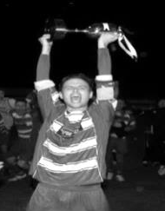
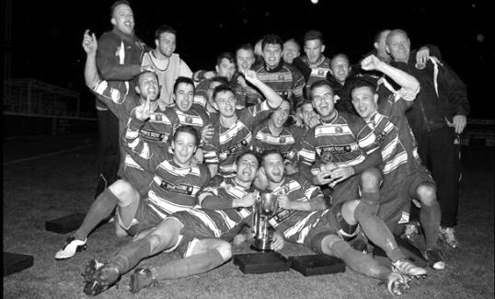
First Round
Camberley Town | 0-3 | Redhill
CB Hounslow United | 5-2 | Eversley & California
South Park Reserves | 3-4 | Horley Town
Staines Lammas | 2-2+ | Chertsey Town
Chertsey Town won 5-4 on penalties
Raynes Park Vale | 3-2 | Hanworth Villa
FC Deportivo Galicia | 1-0 | AC London
Sutton Common Rovers | 3-1 | Westfield
Worcester Park | 4-2 | Epsom & Ewell
Second Round
CB Hounslow United | 1-2+ | Worcester Park
Chertsey Town | 1-0 | Horley Town
Colliers Wood United | 4-1 | Balham
AFC Hayes | 0-1 | Cobham
Knaphill | 3-1 | Guildford City
Cove | 0-1 | Sutton Common Rovers
Bagshot | 1-4 | North Greenford United
Bedfont Sports | 6-1 | Farleigh Rovers
Redhill | 9-0 | Fleet Spurs
Kensington Borough | 4-3 | Raynes Park Vale
Bedfont & Feltham | 0-1 | Godalming Town
Chessington & Hook United | 5-2 | Sheerwater
Spelthorne Sports | 5-1 | Ash United
Walton & Hersham | 6-1 | Badshot Lea
Abbey Rangers | 1-3 | FC Deportivo Galicia
Banstead Athletic | 0-3 | Farnham Town
Third Round
Cobham | 5/12 | Farnham Town
North Greenford United | 14/11 | Colliers Wood United
Sutton Common Rovers | 4/12 | Redhill
Godalming Town | 5/12 | Chessington & Hook United
Knaphill | 21/11 | Kensington Borough
Bedfont Sports | 14/11 | Walton & Hersham
Spelthorne Sports | 28/11 | Chertsey Town
Worcester Park | 9/12 | FC Deportivo Galicia

Centre page for results

Centre page for results




Farnham Town – History
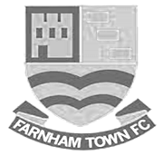
Farnham Town Football Club is a senior level football club based In Farnham, Surrey, England.

Established in 1906 through the merging of Farnham Bungs (the Farnham Brewery) and the Farnham Star. The club was one of the founder members of the London Spartan League in 1975. They reached the Fourth Round of the FA Vase in the 1976-77 season.

At the end of the 1979/80 season Farnham Town left the London Spartan League and applied to the Combined Counties League, their application was accepted and they finished 4th in their first season. The 1986/87 season saw Farnham take second place to Ash United in the league campaign. The glory days finally arrived in the 1990/91 season when the club won the league title. In the 1991/92 season, the Town got a clean sweep of the major trophies by winning the Combined Counties Premier League, the Dan Air Elite Cup and the Dan Air Challenge Cup. Having won the league, the club applied and were accepted to the Diadora League, however funds for necessary ground improvements could not be generated which resulted in the club not having a league to play in for the 1992/93 season.

In 1993/94 Farnham Town were accepted back into the Combined Counties League where they continue to ply their trade. From 1995-1998 Farnham finished in the top six of the Premier Division for three consecutive seasons, in 1998-99 they finished in 13th position, then 10th in 1999-2000 before suffering relegation from the Premier Division in 2000-2001 season. They bounced straight back the following season but then endured four tough seasons back in the Premier Division, with bottom four finishes every season culminating in relegation back down to Division One in 2005-2006. Again, the club bounced straight back and in 2006-2007 they won the Division One title under the guidance of Barry Bridger, but were denied promotion due to the Memorial Ground not meeting the desired grading by the league. The club then spent another four seasons in Combined Counties Division One.

Farnham gained promotion from Combined Counties Division One in the 2010-2011season after finishing second behind Worcester Park. In Paul Tanner’s first season at the helm he gained automatic promotion back to the Premier Division at the first attempt, which after only retaining four members of the side from the previous year’s squad - who finished mid-table, was quite an achievement.

Paul Tanner’s side also won the Combined Counties Fair Play Award for 2010-2011 after going the whole season without having a man sent off, a record to be proud of. In a very successful year for the club on the whole, Dean Nelson’s reserve side finished second behind Mole Valley in the Combined Counties Reserve Division, improving on fourth position the previous season. Farnham Ladies also finished second in their respective league to cap quite a remarkable season in Geoff Chapple’s final season as Chairman. In 2011, Ray Bridger took over as chairman from Geoff Chapple.

The 2015/16 season saw the club lift the Cherry Red Records Premier Challenge Cup whilst also reaching the final of the Aldershot FA Senior Cup

Current first team manager, and now in his 8th season at the club, is Paul Tanner alongside his coaching team of Andy Sharratt, Tony Levey & Paul Bonner.

Combined Counties League Premier Division
Opponents All-time Records
inc Saturday  11th November | P | W | D | L | F | A | PPG | GD | Best  Win | Worst  Loss
Godalming Town** | 1 | 1 | 0 | 0 | 2 | 1 | 3.00 | +1 | 2-1 | X
Abbey Rangers | 4 | 3 | 0 | 1 | 11 | 4 | 2.25 | +7 | 7-1 | 2-3
Sutton Common Rovers | 13 | 9 | 2 | 2 | 30 | 19 | 2.23 | +11 | 4-0 | 0-5
Horley Town | 31 | 21 | 5 | 5 | 69 | 34 | 2.19 | +35 | 6-0 | 1-3
Spelthorne Sports* | 8 | 5 | 2 | 1 | 16 | 11 | 2.13 | +5 | 6-2 | 1-5
Banstead Athletic | 38 | 23 | 7 | 8 | 62 | 38 | 2.00 | +24 | 5-0 | 0-4
Bedfont Sports | 12 | 7 | 2 | 3 | 21 | 19 | 1.92 | +2 | 5-1 | 0-7
Guildford City | 18 | 11 | 1 | 6 | 35 | 22 | 1.89 | +13 | 5-1 | 1-5
Westfield | 21 | 12 | 3 | 6 | 43 | 36 | 1.86 | +7 | 6-1 | 0-4
Colliers Wood United | 24 | 14 | 2 | 8 | 47 | 39 | 1.83 | +8 | 4-0 | 0-5
Knaphill | 9 | 5 | 1 | 3 | 19 | 15 | 1.78 | +4 | 4-0 | 2-6
Farnham Town | 16 | 8 | 4 | 4 | 27 | 25 | 1.75 | +2 | 3-1 | 1-4
Walton & Hersham | 52 | 25 | 11 | 16 | 105 | 99 | 1.65 | +6 | 8-0 | 1-9
Hanworth Villa | 18 | 8 | 5 | 5 | 39 | 28 | 1.61 | +11 | 5-0 | 1-4
Camberley Town* | 91 | 38 | 23 | 29 | 159 | 126 | 1.52 | +33 | 9-1 | 0-4
Redhill | 34 | 14 | 2 | 18 | 63 | 74 | 1.29 | -11 | 7-2 | 2-8
Chertsey Town | 51 | 19 | 5 | 27 | 77 | 95 | 1.22 | -18 | 3-0 | 0-7
North Greenford United | 13 | 4 | 2 | 7 | 19 | 24 | 1.08 | -5 | 3-0 | 1-4
AFC Hayes | 10 | 2 | 3 | 5 | 18 | 18 | 0.90 | 0 | 7-0 | 0-3
CB Hounslow United | 4 | 1 | 0 | 3 | 6 | 11 | 0.75 | -5 | 2-0 | 1-5
Balham | - | - | - | - | - | - | - | - | - | -
* includes one abandoned match v Camberley and one loss on penalties v Spelthorne
** Godalming Town known as Godalming & Guildford when we played them

From behind the goal
Whitstable Town 3-2 Epsom & Ewell - after extra time
Buildbase F.A. Vase - Second Round - Saturday 11th November 2017

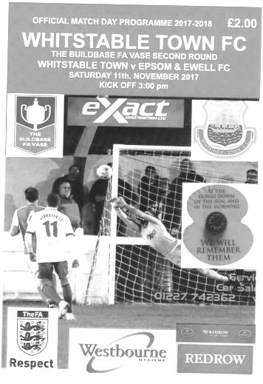
Heroic rear-guard display just falls short

A long trip is a large test of character for the players in any squad and ultimately if a few more of them had bothered to make the journey, we may even have pulled something out of the bag today. Regrettably our Vase journey ended when the squad of just twelve fit men just ran out of energy after a heroic display of defiance over 120 minutes.

Too many times in the last few months it has been next to impossible for Glyn to put any sort of settled side together and this is one of the reasons for our perilous position this season. I'm sure some of our absentees may well have had valid reasons, but we have around 40 players registered this term. To fail to get a full squad on the coach for the biggest match of the season to this point is unacceptable and the players who weren't here really need to be honest with themselves and our Manager as we have a very tough battle ahead. An example of what we are looking for was provided by Scott Murphy who wasn't fit to play, but made the journey with the rest of the squad and sat on the bench in case of an emergency.

In our line-up today were a couple of new boys and an old boy too as George Murphy returned to the starting eleven and played superbly, despite having had very little football in recent months. George will be a massive benefit to our club if he can be available regularly. Of the new faces, Kane Grandison put in a good shift throughout the match, while Joe Jasper came on late in the second half and showed some good touches, despite limited service.

It is somewhat flippant to compare a football match with a World War, but on Remembrance Day there had to be a reference of some sort within the report and it's fair to say that we were heavily outgunned for much of this match, although in the end we nearly forced a replay. In fact, we took the lead in the 13th minute with our first attack when Liam Roberts was brought down in the area as he ran at goal. It looked like a generous decision if I'm honest, but we've had little else in the way of fortune so far this season and more was to follow as in the absence of regular takers Rob Hendry and Kyle Hough, Roberts himself took the kick and scuffed it horribly straight at the keeper, but it didn't stick and as it came back out he was able to take full advantage of the second opportunity from close range.

Conor Young was finding himself very busy once again and produced a good save from a close range shot after the Oystermen had broken through on the left, but most of the threat came from the right wing and in the 22nd minute the home side were level when a ball in from the right to Josh Burchell was held up nicely before he turned our man and fired past our keeper from close range.

The pressure continued and Alex McKay was well positioned to make a block of the goalbound shot on the half hour with another close range strike finding our side netting soon after this. Our opportunities were rare, although Dale Marvell had a chance with a free kick which was on target

for the top corner but was just blocked by the very top of the defensive wall, although the ball wasn't cleared and we attacked again with Sean White seeing his shot blocked over the bar and Murphy also got a header on target but it was lacking in power and the ball was caught on the line.

The second half continued in a similar pattern with the home side pushing us back and they took the lead in the 57th minute. When the goal came it was a bit of a surprise though, as a harmless looking ball was fed in from the left but it wasn't dealt with and fell to Tijan Jadama who turned the ball into the corner of the net from about eight yards out. It was hard to argue with the score at this point and I wondered whether our chance had gone.

However, the Oystermen seemed to go into their shells for a while as they started to slow the game down. This certainly gave me the impression that they were looking to hold what they had instead of looking for more. After a spell where nothing much happened and in an attacking move, we introduced Jasper in place of the hard-working Dan Rose with ten minutes remaining and three minutes later had our reward.

There have been few players this season that have faced such a baptism of fire as Ben Dyson. A young lad who joined us from the Leatherhead academy, he has been played in a number of positions this season and at times hasn't been given an enormous amount of help by his teammates when playing as left back or right back, yet he has got on with things, worked hard and remained committed to the club cause. As a result it was great to see him score his first goal for the club and our equaliser in the 83rd minute as a Roberts corner was driven to the near post and the connection was perfect, sending the ball flying into the roof of the Whitstable net to make the score 2-2. I wasn't totally convinced that Roberts meant to put the corner there, but we'll give him the benefit of the doubt!

This had the effect of waking the home side up again and a couple of dangerous balls in were headed wide but the damage had been done and we had managed to force extra time. Bearing in mind that we had already used our substitute, I thought we might have pushed a bit more in those closing moments of the first ninety minutes to try and win the tie but we seemed happy enough to go for the extra period.

Twelve years ago, we had departed the Vase in extra time just up the road at Herne Bay, and we faced a similar type of barrage in the extra period here. Young made two fine saves within a minute from a near post header and then a twenty-five yard strike that he tipped over, but the home side appeared to be running out of ideas as a couple of efforts sailed high and wide.

Regrettably, in the second period of extra time and just as thoughts began to turn towards a Tuesday replay, they scored what proved to be the winner in the 108th minute when we didn't cut out a left wing cross which Tom Bryant then headed in from close range. A fourth nearly followed with another header from a far post corner but Young was well positioned to make the save. Moments later the ball was in our net but Young was adjudged to have been fouled in the process and the free kick was awarded in our favour.

We had one final opportunity to level the scores with two minutes remaining when McKay flicked on a Lloyd Connelly free kick to Dyson but he was at a wide angle and his shot fizzed across the six yard box and out the other side. Ultimately the better side had won, but the Vase can sometimes throw out strange results and we were ever so close to achieving one that would have been remembered for many years, bearing in mind how low on numbers we were on the day.

Epsom and Ewell: Conor Young, Ben Dyson, Liam Roberts, Alex McKay (c),
George Murphy, Dale Marvell, Dan Rose, Kane Grandison, Sean White,
Lloyd Connelly, Ashley Thompson

Sub: Joe Jasper for Rose (80)

Every Opponent A-Z
Over the years we have played many, many different opponents. Exactly how many is a difficult question, as it all depends on your definition. Are Camberley & Yorktown different to Camberley Town, or are Epsom Town different to Epsom F.C. or Epsom & Ewell F.C.?

In my analysis I have classed them as the same team, and will work through them all from A to Z. Some we have played many times, whilst others we have met maybe just once or twice. Enjoy!


Weybridge: Played 8 - W6 D1 L1 - F29 A4 - PPG - 2.38 - Fantastic

Weybridge were a very old team that had actually been the best team in the County around the turn of the Twentieth Century. One of our predecessors Ewell F.C. met them and lost 2-0 in the Final of the 1899 Surrey Senior Cup, but by the time Epsom met them in the mid-Twenties, they were a very average Surrey Senior League club, having watched many clubs pass them on their way up to the Athenian and Isthmian Leagues.

The first meeting, in our inaugural Senior season finished 1-1 at West Street on 20th September 1924 and in November of the same year a Reg Sperring goal wasn’t enough as we lost 2-1 in the Surrey Senior Cup, also at Ewell. From that point however, results were decidedly in our favour, including our first visit to the town which ended 5-0 to us.

In 1925/26 we again met three times, this time we gained revenge in the Surrey Senior Cup, winning 1-0 in Weybridge just seven days after we had won there by the same score in the League. We edged the return match 2-1 at home but in 1926/27 we destroyed them home and away, 8-0 on 8th January 1927 at Weybridge and 10-0 at West Street on 5th March 1927 with Reg Marlow scoring seven of the eighteen goals on his way to a club record of 65 that season.

The name of Weybridge continued until 1930 when they disappeared from the Surrey Senior League, despite finishing fourth that season, presumably folding. There have been other clubs from that area, including Bae Weybridge, who started life as BAC Weybridge and entered the Surrey Senior League in 1964, while of course there was Addlestone and Weybridge from 1980/81 but it’s not clear why the Weybridge was added; whether it was some sort of club merger or, as was the case with Epsom & Ewell, an attempt to gain support across a greater area, but either way, by the end of the eighties that club was gone too.

Whitehawk: Played 5 - W2 D3 L0 - F9 A7 - PPG - 1.80 - Good

These days Whitehawk are playing their football at the rarefied level of Step Two in the National League South, but for much of their existence they were a tiny Sussex League club. We met them for the first time on 1st October 1960 in the Preliminary Round of the Amateur Cup, narrowly squeaking through 3-2 with two goals from Bill Hawkins and one from Dennis Wells.

However, it was the other meeting that caused the most interest as we were paired together once more in the same competition in 1969/70, this time at East Brighton Park, where they remain to this day. We drew 2-2 there with goals from Ken Jolly and Dave Morrish but the replay at West Street was almost a carbon copy as the score was the same, as were our scorers! There was no further scoring in extra time and a second replay was held at Queen Street, home of Horsham, but this too was drawn 1-1 after extra time, again with our boys unable to hold on to a lead. Finally, a third replay was required and so two weeks after the original tie we all went back down to Brighton where a Morrish goal finally settled the tie in our favour. A week later Tooting & Mitcham United knocked us out in the next round anyway!

Whitstable Town: Played 3 - W0 D1 L2 - F3 A7 - PPG - 0.33 - Horrible

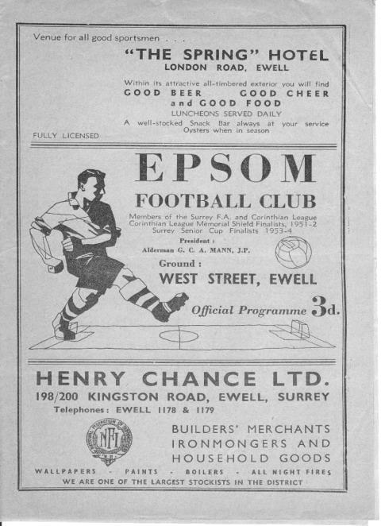
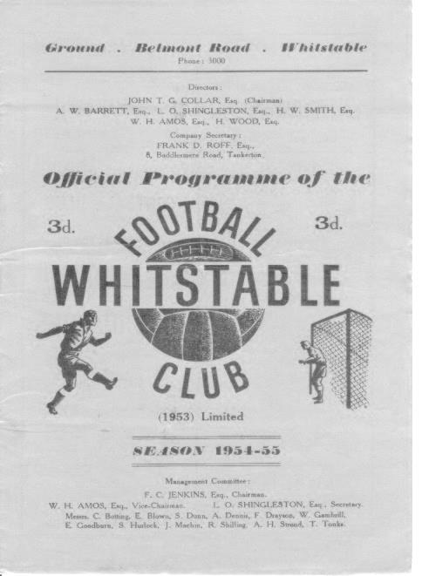

We have of course just met Whitstable Town for the third time, losing narrowly 3-2 after extra time on Saturday. Had there been no extra time though, we would have taken them to a home replay, which was what happened back in 1954 when the two teams were paired in the F.A. Cup.

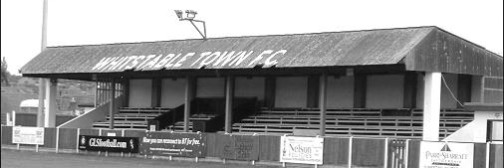
On 25th September 1954 we recorded our first goalless draw since 1937, a club record seventeen years, which is very impressive even allowing for a six year World War Two break. Unfortunately, we were unable to hold the professional Kent League team in the replay and were beaten 4-1 with former Hendon winger Bobby Avis scoring our goal. (see programmes from the two matches)

In the last decade Whitstable have been up in the Isthmian League South Division but relegation in 2016 placed them back in the equivalent of the old Kent League, the Southern Counties Football League East, which is of course how we met in the Vase last week. However, the ground remains a real gem with traditional fifties constructions everywhere, including the picturesque old stand.

Player Sponsorship
Here is the latest list for 2017/18, with new photos showing all of our players and Management that are available for sponsorship.

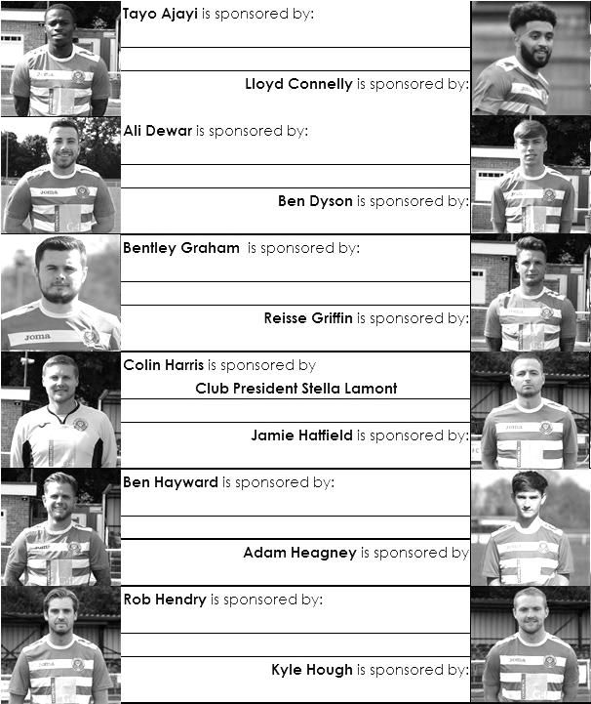

Sponsorship costs just £40 and it is easy to do. Just select a player who has not been previously sponsored and let a Committee Member know that you would like to sponsor them. Beware though. Until we have received the money it is possible for someone to jump in front of you, so don’t delay, sponsor today!

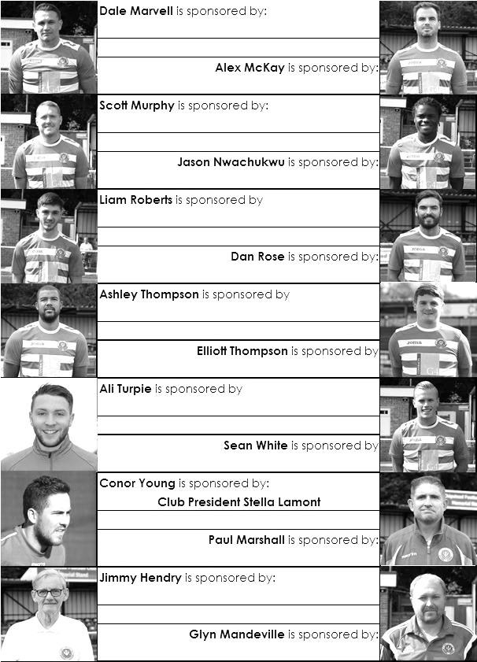

CCL Premier Division Club Directory
ABBEY RANGERS Telephone: 01932-422962 - Colours: Black & White Stripes/Black/Black
Ground: Addlestone Moor, Addlestone. KT15 2QH

A.F.C. HAYES Telephone: 0208-845-0110 - Colours: Blue and White Stripes/Blue/Blue
Ground: Farm Park, Kingshill Avenue, Hayes. UB4 8DD

BALHAM Telephone: 0208-942 8062 - Colours: White & Black/Black/Black

Ground: Colliers Wood United FC - Wibbandune, Robin Hood Way, Wimbledon. SW20 0AA -

BANSTEAD ATHLETIC Telephone: 01737-350982 - Colours: Amber &Black/Black/Black
Ground: Banstead Athletic, Merland Rise, Tadworth. KT20 5JG

BEDFONT SPORTS Telephone: 0208-831-9067 - Colours: Red & Black Hoops/Black/Red & Black
Ground: Bedfont Sports Club, Hatton Road, Bedfont. TW14 8JA

CAMBERLEY TOWN Telephone: 01276-65392 Colours: Red & White Stripes/Blue/Red
Ground: Krooner Park, Wilton Road, Camberley. GU15 2QW

CB HOUNSLOW UNITED Telephone: 0208-577 -9712 Colours: Green/Black/Green
Ground: CB Hounslow Sports Ground, Green Lane, Hounslow TW4 6DH

CHERTSEY TOWN Telephone: 01932-561774 - Colours: Royal Blue & White Stripes/ Blue/ Blue
Ground: Alwyns Lane, Chertsey. KT16 9DW

COLLIERS WOOD UNITED Telephone: 0208-942 8062 - Colours: Royal Blue/Black/Black
Ground: Wibbandune, Robin Hood Way, Wimbledon. SW20 0AA

EPSOM & EWELL Telephone: 01737-553250 - Colours: Royal Blue & White Hoops/Royal Blue/Royal Blue - Ground: Chipstead FC, High Road, Chipstead. CR5 3SF

FARNHAM TOWN Telephone: 01252-715305 - Colours: - Claret & Sky Blue /White/ Claret & Blue
Ground: Memorial Ground, Babbs Mead, West Street, Farnham. GU9 7DY

GODALMING TOWN Telephone: 01483-417520 - Colours: Yellow/Green/Yellow
Ground: Wey Court, Meadrow, Godalming. GU7 3JE

GUILDFORD CITY Telephone: 01483-443322 - Colours: Red & White Stripes/Black/Black
Ground: The Spectrum, Parkway, Guildford, Surrey. GU1 1UP

HANWORTH VILLA Telephone: 0208-831-9391 - Colours: Red & White Stripes/Black/Black
Ground: Rectory Meadows, Park Road, off Hounslow Road, Hanworth. TW13 6PN

HORLEY TOWN Telephone: 01293-822000 - Colours: Claret & Sky Blue/Claret/Claret
Ground: The New Defence, Anderson Way, Court Lodge Road, Horley. RH6 8SP

KNAPHILL Telephone: 01483-475150 - Colours: Red/Black/Red & Black
Ground: Brookwood Country Park, Redding Way, Lower Guildford Road, Knaphill. GU21 2AY

NORTH GREENFORD UNITED Telephone: 0208 422 8923 - Colours: Royal Blue & White/Royal Blue/Royal Blue - Ground: Berkeley Fields, Berkeley Avenue, Greenford, Middx UB6 0NX

REDHILL Telephone: 01737-762129 - Colours: Red and White Stripes/Red/Red
Ground: Kiln Brow, Three Arch Road, Redhill. RH1 5AG

SPELTHORNE SPORTS Telephone: 01932-961055 - Colours: Navy & Sky Blue/ Blue/ Blue
Ground: Spelthorne Sports Club, 296 Staines Road, Ashford Common, Ashford. TW15 1RY

SUTTON COMMON ROVERS Telephone: 0208-644-4440 - Colours: Yellow/ Yellow / Yellow
Ground: Sutton United FC, Gander Green Lane, Sutton. SM1 2EY

WALTON & HERSHAM Telephone: 01932-245263 - Colours: Red & White Trim/Red/Red
Ground: Stompond Lane, Walton on Thames. KT12 1HF

WESTFIELD Telephone: 01483-771106 - Colours: Yellow/Black/Black
Ground: Woking Park, Kingfield Road, Woking. GU22 9BA

Match and Ball Sponsorships – 2017/18
Opponent | Date | Match Sponsor | Ball Sponsor
Banstead Athletic (FAC) | 06/08/17 | Club President - Stella Lamont
Chertsey Town | 15/08/17 | EEFC Management Committee
Redhill | 02/09/17 | Building Shop Ltd
Spelthorne Sports | 09/09/17 | In memory of Betty Dyke
Horley Town | 12/09/17 | Alex McKay (Senior)
Hanworth Villa | 23/09/17 | Jack Jarman
North Greenford United | 28/10/17 | Marvin and Kathy Hough
Farnham Town | 14/11/17 | In memory of Dave and Lizzie Marshall
Godalming Town | 21/11/17 | Building Shop Ltd
Guildford City | 02/12/17
Abbey Rangers | 16/12/17
Walton & Hersham | 30/12/17
Balham | 20/01/18
Sutton Common Rovers | 03/02/18
CB Hounslow United | 13/02/18
Knaphill | 24/02/18
Camberley Town | 10/03/18
Bedfont Sports | 24/03/18
Colliers Wood United | 30/03/18
Banstead Athletic | 02/04/18 | Nathan Lambert – 10 years old today!
Westfield | 14/04/18
AFC Hayes | 28/04/18 | Club President - Stella Lamont
Match sponsorship costs just £60.00.

Sponsorship includes:

Admission, programmes and hospitality for three people.

A full page advert in the programme and mascot for the day (if required).

Also, you get to choose the player of the match, who will receive a prize

If you are interested, just speak to a Committee Member,
or drop me an email at: richard.c.lambert@gmail.com

Salts Super Six Predictor
The Salts Super Six Predictor was claimed last week and John Fidler won the largest prize we have offered in decades of £630! Congratulations to him.

We are now live again today with a jackpot of £100 and the tickets are on sale at today’s game to the left of the gate. The matches are to be played this Saturday.

The competition is easy to play! To win, you simply need to predict the results of six matches correctly from the three options, fill in the form and make sure it is back with our seller before the deadline on the ticket. The latest fixtures are shown below.

If you are a club regular, you just need to place your name on the sheet, although if you aren’t, then we’ll need a contact number from you too. We will announce any winners on the website within three working days, so don’t worry, we won’t miss you!

Please note that if there is more than one winner, the prize pot would be shared between the winners. All you need to do now is have a go, as many times as you like!

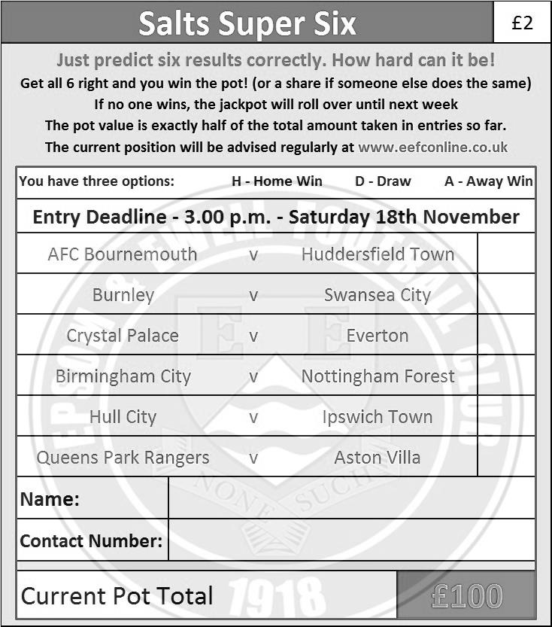

Good luck!

Merchandise
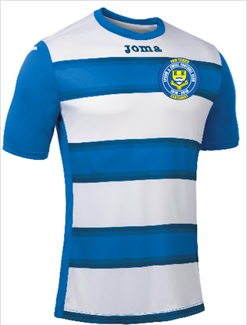
To celebrate our Centenary season we are shortly to have a new kit which will also contain our brand new Centenary badge. We will also be selling polo shirts in either Royal Blue or White.

The costs are being finalised now but if you would like to purchase either a replica new shirt or polo shirts, then let us know and we will get them to you for Christmas or maybe just afterwards. You know where we are!

Be part of the Salts Centenary!

#Saltsfamily

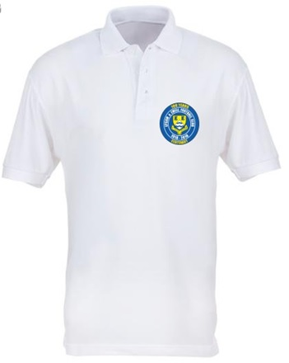
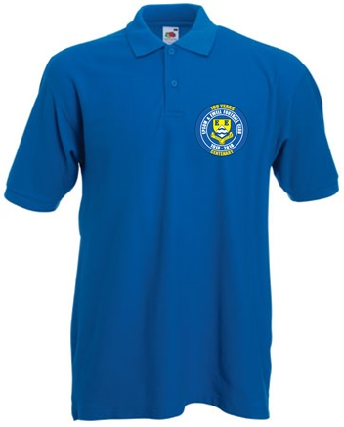

Combined Counties League – Premier Division
Tuesday, 14th November 2017 - Kick-off 7.45 p.m.
Epsom and Ewell  (Royal Blue & White hoops) | V |  | Farnham Town  (Claret / Blue)
Squad | NUMBERS |  | Squad
Conor Young |  |  | Adrian Giles
Adam Heagney |  |  | James Flynn
© Jamie Hatfield |  |  | Tom Smith
Reisse Griffin |  |  | George Spiers
Scott Murphy |  |  | Doug Ford
Dale Marvell |  |  | Max Meaton
Liam Roberts |  |  | Nick Medcraft
Ashley Thompson |  |  | Adam Horton
Kyle Hough |  |  | Elliot Cardona
Sean White |  |  | Ashley Peck
Rob Hendry |  |  | Jack Dillon
Jason Nwachukwu |  |  | Jack Cox
Daniel Rose |  |  | Joshua Tarrant
Ben Dyson |  |  | Steve Ramsden
Alex McKay |  |  | Sam Slater
Lloyd Connelly |  |  | Joshua Stepney
David Thomson
Kane Grandison
Taryn Smith
Tayo Ajayi
Ben Hayward
Alistair Turpie
Ali Dewar
Colin Harris
Glyn Mandeville | MANAGER |  | Paul Tanner
Alex McKay | ASSISTANT
Neil Grant / Jimmy Hendry | COACHES / PHYSIO
REFEREE: M.Williams
ASSISTANTS: J.Lidbetter, M.Diliwari
Today’s Match and Match Ball are kindly sponsored:
In memory of Dave and Lizzie Marshall

OUR NEXT VISITORS TO HIGH ROAD
Godalming Town
Cherry Red Combined Counties League – Premier Division
Tuesday 21st November 2017 – 7.45 p.m.

